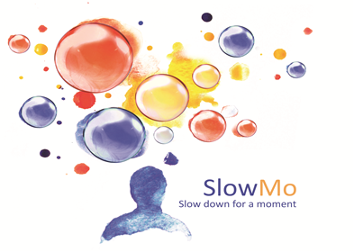

Sponsor(s): King’s College London & South London and Maudsley NHS Foundation Trust

Study title: The SlowMo Trial: A randomised controlled trial of a digital therapy for people who fear harm from others

IRAS number: 206680.

How your personal data will be used in compliance with General Data Protection Regulation (GDPR)

King’s College London (KCL) is the lead sponsor for this study based in the United Kingdom. We will be using information from you and your medical records in order to undertake this study and will act as the data controller for this study. This means that we are responsible for looking after your information and using it properly. KCL will keep identifiable information about you for seven years after the study has finished. Your rights to access, change or move your information are limited, as we need to manage your information in specific ways in order for the research to be reliable and accurate. If you withdraw from the study, data collected up to the point of withdrawal will be used unless you tell us not to. To safeguard your rights, we will use the minimum personally-identifiable information possible.
You can find out more about how we use your information by contacting the Chief Investigator Professor Philippa Garety (Philippa.garety@kcl.ac.uk) or visiting the KCL website: https://www.kcl.ac.uk/research/support/research-ethics/kings-college-london-statement-on-use-of-personal-data-in-research.aspx.

South London and Maudsley NHS Foundation Trust will collect information from you [and/or your medical records] for this research study in accordance with our instructions.

The South London and Maudsley NHS Foundation Trust will use your name, NHS number, Trust ID and contact details to contact you about the research study, and make sure that relevant information about the study is recorded for your care, and to oversee the quality of the study. Individuals from King’s College London and regulatory organisations may look at your medical and research records to check the accuracy of the research study. The South London and Maudsley NHS Foundation Trust will pass these details to King’s College London along with the information collected from you and/or your medical records. The only people in King’s College London who will have access to information that identifies you will be people who need to contact you, for example to provide an update on the outcome of the study or audit the data collection process.
The people who analyse the information will be analysing data that cannot be used to identify you and will not contain your name, NHS number or contact details.

King’s College London will keep identifiable information about you from this study for seven years after the study has finished.

