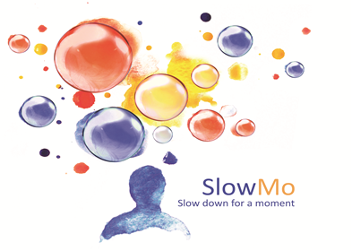

Sponsor(s): King’s College London & South London and Maudsley NHS Foundation Trust

Study title: The SlowMo Trial: A randomised controlled trial of a digital therapy for people who fear harm from others

IRAS number: 206680.

Using your data for future research
As a University we use personally-identifiable information to conduct research to improve health, care and services. As a publicly-funded organisation, we have to ensure that it is in the public interest when we use personally-identifiable information from people who have agreed to take part in research. This means that when you agree to take part in a research study, we will use your data in the ways needed to conduct and analyse the research study. Your rights to access, change or move your information are limited, as we need to manage your information in specific ways in order for the research to be reliable and accurate. If you withdraw from the study, data collected up to the point of withdrawal will be used unless you tell us not to. To safeguard your rights, we will use the minimum personally-identifiable information possible.
Health and care research should serve the public interest, which means that we have to demonstrate that our research serves the interests of society as a whole. We do this by following the UK Policy Framework for Health and Social Care Research.
If you wish to raise a complaint on how we have handled your personal data, you can contact our Data Protection Officer who will investigate the matter. If you are not satisfied with our response or believe we are processing your personal data in a way that is not lawful you can complain to the Information Commissioner’s Office (ICO).
Our Data Protection Officer is Mr Albert Chan and you can contact them at info-compliance@kcl.ac.uk.
When you agree to take part in a research study, the information about your health and care may be provided to researchers running other research studies in this organisation and in other organisations. These organisations may be universities, NHS organisations or companies involved in health and care research in this country or abroad. Your information will only be used by organisations and researchers to conduct research in accordance with the UK Policy Framework for Health and Social Care Research.
This information will not identify you and will not be combined with other information in a way that could identify you. The information will only be used for the purpose of health and care research, and cannot be used to contact you or to affect your care. It will not be used to make decisions about future services available to you, such as insurance.

